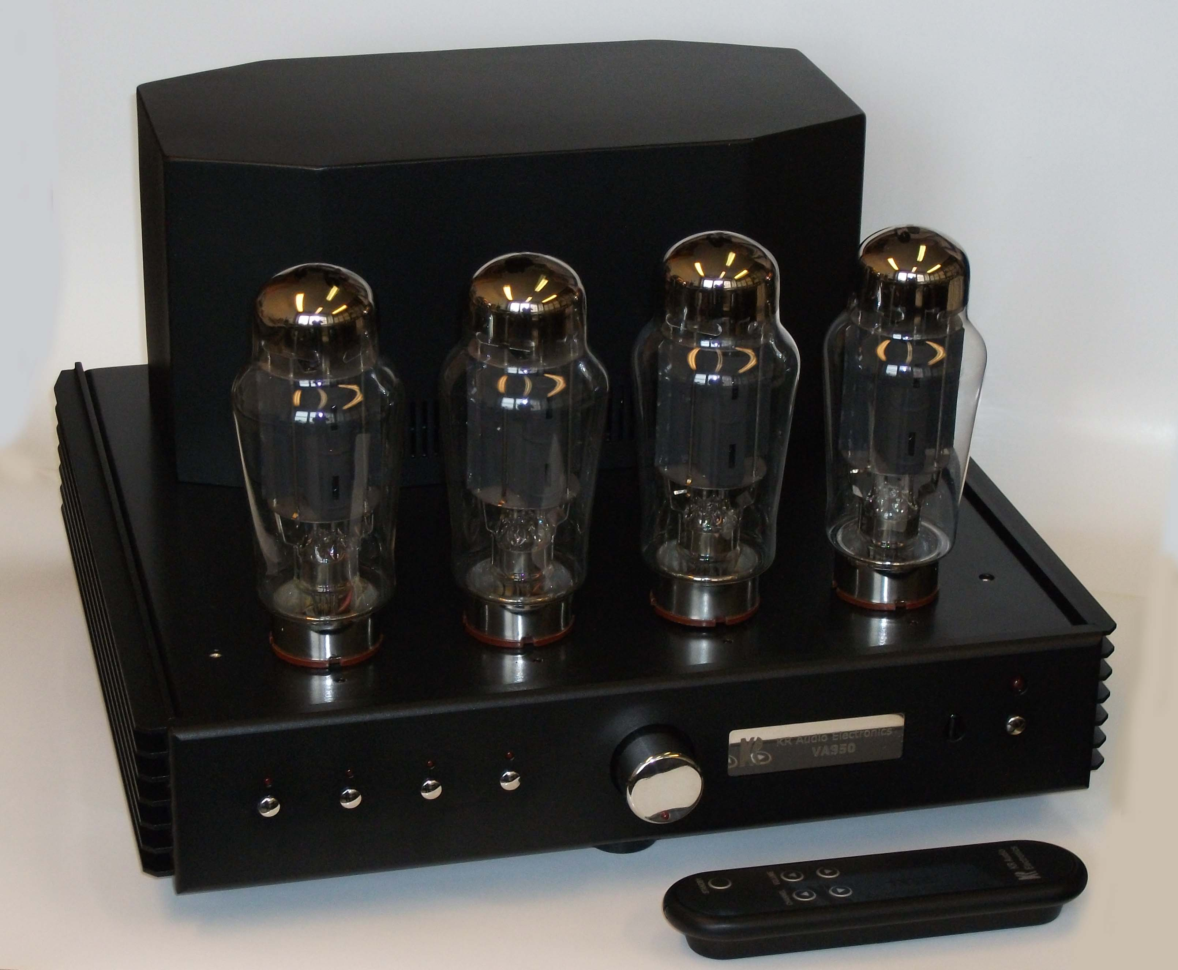

VA950

Stereo Integrated Amplifier

Technical Data

Power Tubes 4 x KT150

Output stage Push-Pull Ultra-linear Class AB1
Output Power 2 x 100 W_{RMS} (THD=1%)
Output Impedance 4, 8 Ω
Frequency Response 20Hz ÷20KHz (-1dB)
Feedback 7dB
Driver stage MOSFET class A
Preamplifier solid-state with mechanical (reed) relays
Remote Control volume & channel selector
Inputs 4 x line RCA (Cinch)
Input Sensitivity 0.75V_{RMS}/47kΩ (all channels)
Power requirements 230/115V_{AC}, 50/60 Hz
Power consumption 500VA
Operating temperature 5C° to 40C°
Weight Approx. 25Kg
Dimensions including projecting parts and controls (w/h/d)

Approx. 38.5 x 24.5 x 41.5 cm

